PROJECT REPORT
Global EV Market Analysis
Performance, Pricing, Battery Technology and Sales
Data Analytics with Tableau
Report detail | Information
Project title | Global EV Market Analysis: Performance, Pricing, Battery Technology and Sales
Technology | Python, SQL (SQLite), Tableau Public, Flask
Dataset | ev_market_test.csv provided by Skill Wallet; synthetic data, 100,000 rows x 37 columns
Prepared by | Jumana baghwala
Team ID | [Enter Team ID]
Institution / course | [Enter university, department and course]
Submission date | [Enter required submission date]
GitHub repository | https://github.com/jumanaabw/ev-market-project/upload/main
Tableau dashboard | https://public.tableau.com/views/EVMarketAnalysis_17926786113420/MarketOverview
Tableau story | https://public.tableau.com/views/EVMarketAnalysis_17926786113420/Story1

SmartBridge Skill Wallet project: Data Analytics with Tableau

TABLE OF CONTENTS
1. INTRODUCTION: 1.1 Project Overview, 1.2 Purpose
2. IDEATION PHASE: 2.1 Problem Statement, 2.2 Empathy Map Canvas, 2.3 Brainstorming
3. REQUIREMENT ANALYSIS: 3.1 Customer Journey Map, 3.2 Solution Requirement, 3.3 Data Flow Diagram, 3.4 Technology Stack
4. PROJECT DESIGN: 4.1 Problem-Solution Fit, 4.2 Proposed Solution, 4.3 Solution Architecture
5. PROJECT PLANNING & SCHEDULING: 5.1 Project Planning
6. FUNCTIONAL AND PERFORMANCE TESTING: 6.1 Performance Testing
7. RESULTS: 7.1 Output Screenshots
8. ADVANTAGES & DISADVANTAGES
9. CONCLUSION
10. FUTURE SCOPE
11. APPENDIX: Source Code, Dataset Link, GitHub & Project Demo Link

1. INTRODUCTION

1.1 Project Overview
Electric vehicles are becoming a mainstream product, but manufacturers, policy makers and buyers still struggle to compare the market. Models vary widely in price, range, battery chemistry, charging speed and sales. This project analyses the Skill Wallet EV dataset of 100,000 models from 200 manufacturers (model years 2018 to 2026) in 15 categories, sold across 7 market regions and built in 10 countries.
The data was loaded into a SQLite database with Python and pandas, analysed with SQL, visualized in Tableau Public as 12 worksheets, dashboards and a six-scene story, and published in a Flask web app using the Tableau Embedding API.

1.2 Purpose
- Measure the size and structure of the EV market by category, manufacturer, region and country.
- Understand how price relates to range, battery capacity and motor power.
- Compare battery technologies (NMC, LFP, NCA, Sodium-Ion, Solid-State) on durability and charging.
- Identify high-value vehicles and the environmental impact (CO2 saved).
- Deliver the findings as an interactive Tableau dashboard and story embedded in a Flask web app.

2. IDEATION PHASE

2.1 Problem Statement
The EV market has many models with different prices, ranges, batteries and sales. In raw tables it is hard to know which vehicle types sell best, what drives price and which battery technologies last longest. Global EV Market Analysis brings these measures into one interactive view.
PS | I am | I'm trying to | But | Because | Which makes me feel
PS-1 | a vehicle manufacturer's product planner | compare EV models by category, price, range and battery type | 100,000 models in raw tables are hard to compare | the data sits across 37 columns with no single view | overwhelmed
PS-2 | a policy maker or sustainability analyst | see which categories and regions drive sales and CO2 savings | static reports cannot be filtered | the data needs interactive filtering | frustrated
PS-3 | a prospective EV buyer | find good range and long-lasting batteries for my budget | prices run from about $2.5k to $274k and battery claims are hard to compare | price, range and battery are not linked in one view | confused about value

2.2 Empathy Map Canvas
Empathy-map area | EV market analyst (design hypothesis)
Says | "I cannot compare models from a raw 100,000-row table." "Which battery type lasts longest?"
Thinks | "Does paying more buy more range?" "Which regions and categories matter most?"
Does | Compares models by category, manufacturer and region; filters by year, battery type and price segment; checks CO2 saved.
Feels | Overwhelmed by 200 manufacturers and 37 attributes; more confident with clear interactive visuals.
Needs / pain points | Clear comparisons, interactive filters, readable charts and a visible data limitation note.

Note: this empathy map is a design hypothesis for the intended dashboard viewer, not the result of a formal user interview.

2.3 Brainstorming
- Interactive Tableau dashboard of the global EV market with six shared filters.
- Sales by category and manufacturer, plus a map of manufacturing countries and a regional comparison.
- Battery technology comparison on cycle life, degradation and fast charging.
- Price vs range and battery capacity analysis; CO2 saved by category.
- A Flask web app to publish the dashboard and the story.

3. REQUIREMENT ANALYSIS

3.1 Customer Journey Map
Stage | User action | Potential friction | Design response
Open dashboard | Views the title and category sales | Unclear scope of 100,000 models | Clear title and a Market Overview first
Explore overview | Reviews sales by category, year and manufacturer | 200 manufacturers are too many to read | Top N filter and sorted bars
Filter data | Selects year, region, category, battery type, price segment or manufacturer | Filter may not affect every chart | Six filters shared across worksheets
Investigate | Opens price vs range, battery durability or CO2 charts | Outliers such as buses and trucks distort charts | Compare within category
Interpret | Compares groups and categories | May treat synthetic totals as real | State that totals are relative measures
Finish | Opens the story or shares the link | Cannot find the same view later | Published dashboard and story links

3.2 Solution Requirement
ID | Requirement | Priority | Acceptance evidence
FR-01 | Load the 100,000-row CSV into a database table | High | Figure with 100,000 rows stored in ev_market
FR-02 | Check missing values, duplicates and outliers | High | Data preparation document
FR-03 | Run SQL queries for counts, aggregation, grouping, sorting and a clean view | High | Query output screenshots
FR-04 | Connect the data to Tableau Public and create 6 calculated fields | High | Calculated field list
FR-05 | Build 12 worksheets, dashboards and a six-scene story | High | Published dashboard and story links
FR-06 | Provide six filters: year, region, category, battery type, price segment, manufacturer | High | Filters shown on the dashboard
FR-07 | Embed the dashboard and story in a Flask app with four pages | High | Home, Dashboard and Story page screenshots
NFR-01 | Usability: understandable without extensive explanation | High | Clear captions and titles
NFR-02 | Reliability: workbook opens with no broken fields | High | Dashboard renders on Tableau Public
NFR-03 | Performance: responsive with 100,000 rows | Medium | Top N filter and shared filters
NFR-04 | Data ethics: synthetic-data limitation stated | High | Limitation note in the report

3.3 Data Flow Diagram
Logical flow (text representation):
ev_market_test.csv → pandas → SQLite table ev_market → SQL queries and view vw_ev_clean → Tableau Public (CSV connection) → 12 worksheets and calculated fields → dashboards and story → Flask app (Tableau Embedding API) → viewer
External entity: the analyst or viewer. Data stores: the CSV file, ev_market.db and the Tableau workbook. Processes: load, check, query, connect, visualize and embed. No live link to an external database or API is used.

3.4 Technology Stack
Layer | Technology / component | Role
Source data | ev_market_test.csv (Skill Wallet) | 100,000 EV records, 37 attributes
Data loading | Python and pandas | Read CSV and write the table
Database | SQLite (ev_market.db); MySQL version in the repository | Store table and view; run SQL
BI development | Tableau Public | Worksheets, dashboards, story, calculated fields
Web integration | Flask and the Tableau Embedding API v3 | Host the Home, Dashboard, Story and About pages
Version control | GitHub | Code, SQL scripts and documentation

4. PROJECT DESIGN

4.1 Problem-Solution Fit
Observed need | Project response | How to evaluate
Know which vehicle types sell best | Sales by Category and Top Manufacturers | Compare with SQL queries 2 and 3
Understand what drives price | Price vs Range scatter and correlation check | Correlation 0.84 with capacity, 0.28 with range
Choose a durable battery | Battery Durability bars | Compare with SQL query 4
Compare regions and countries | Country map and Average Price by Region | Compare with SQL query 5
Explore subsets | Six shared filters | Dashboard filter panel
Understand limitations | Synthetic-data note | Limitation stated in the report

4.2 Proposed Solution
Load the EV CSV into a SQLite database, check data quality, and run SQL queries and a clean view. Connect the same data to Tableau Public, create six calculated fields and build 12 worksheets with six shared filters. Combine them into dashboards and a six-scene story, publish both, and embed them in a Flask web app with four pages.

4.3 Solution Architecture
Step | Component | Description
1 | Data source | ev_market_test.csv: 100,000 rows x 37 columns, 2018 to 2026.
2 | Database | pandas loads the CSV into SQLite table ev_market.
3 | Quality checks | Five columns with under 3.1% nulls; vehicle_id unique; outliers kept by design.
4 | Analysis layer | Eight SQL queries and the view vw_ev_clean.
5 | Visualization layer | Tableau Public: 6 calculated fields, 12 worksheets, six filters.
6 | Dashboard and story | Interactive dashboards and a six-scene story published on Tableau Public.
7 | Web integration | Flask app embeds both with the Tableau Embedding API.

5. PROJECT PLANNING & SCHEDULING

5.1 Project Planning
Phase | Key tasks | Deliverable | Status
1. Data understanding | Confirm source, schema and row/column count | Dataset profile | Completed
2. Data quality | Inspect nulls, duplicates and outliers | Quality-check record | Completed
3. Database and SQL | Load into SQLite and run eight queries and a view | ev_market.db and query outputs | Completed
4. Worksheet development | Create calculated fields and 12 worksheets | Worksheet set | Completed
5. Dashboard and story | Combine worksheets with six filters; build six scenes | Published dashboard and story | Completed
6. Web integration | Build four Flask pages with embedded Tableau | Flask app | Completed
7. Final report | Add screenshots, results and links | Submission package | Completed

A detailed backlog with four sprints and 51 story points is in the Project Planning document.

6. FUNCTIONAL AND PERFORMANCE TESTING

6.1 Performance Testing
Parameter | Value
Rows rendered | 100,000
Columns | 37
Data filters used | 6
Calculated fields | 6
Visualizations | 12
Story scenes | 6
Web pages (Flask) | 4

To keep the dashboards responsive, charts that show 200 manufacturers are limited with a Top N filter, filters are shared across worksheets, and the scatter plot uses a single mark per model only where needed.

7. RESULTS

7.1 Output Screenshots
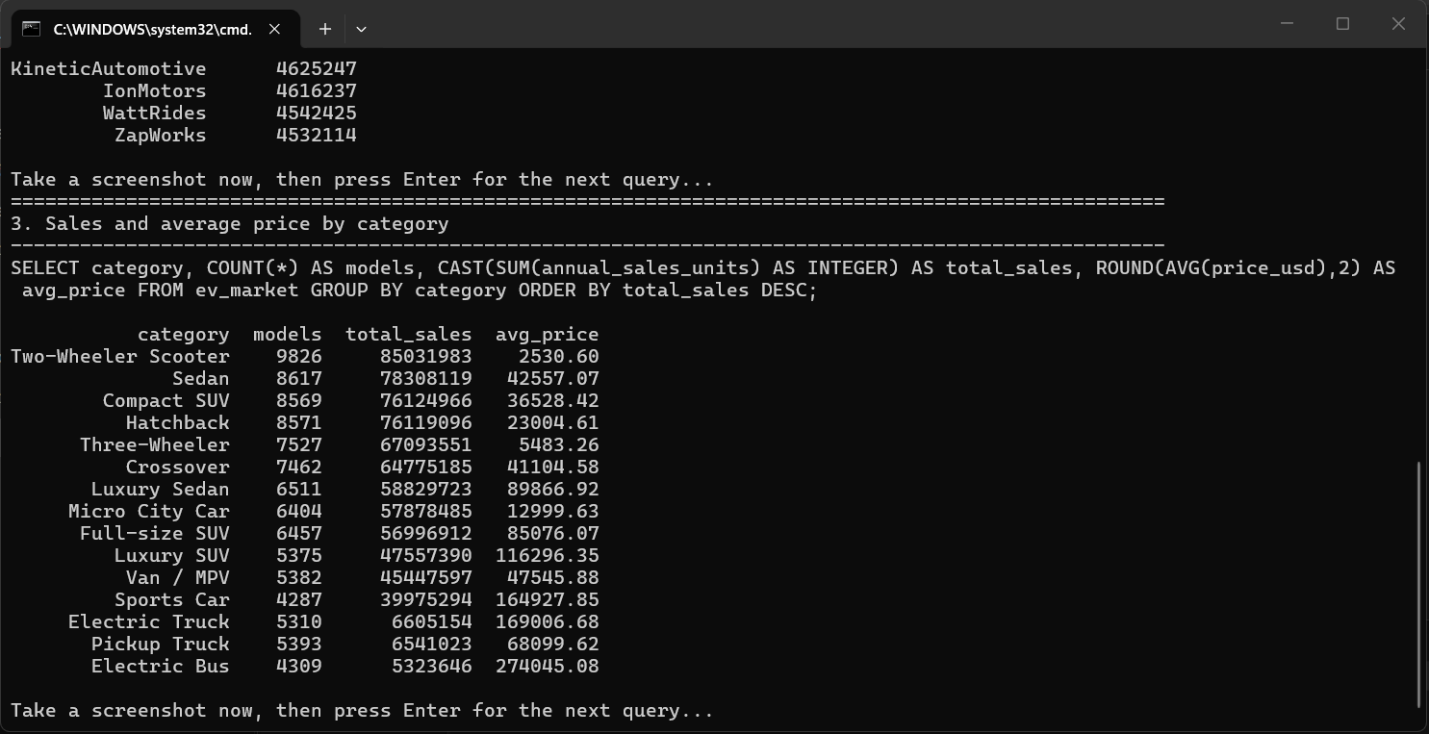
Figure 1. SQL output: sales and average price by category.
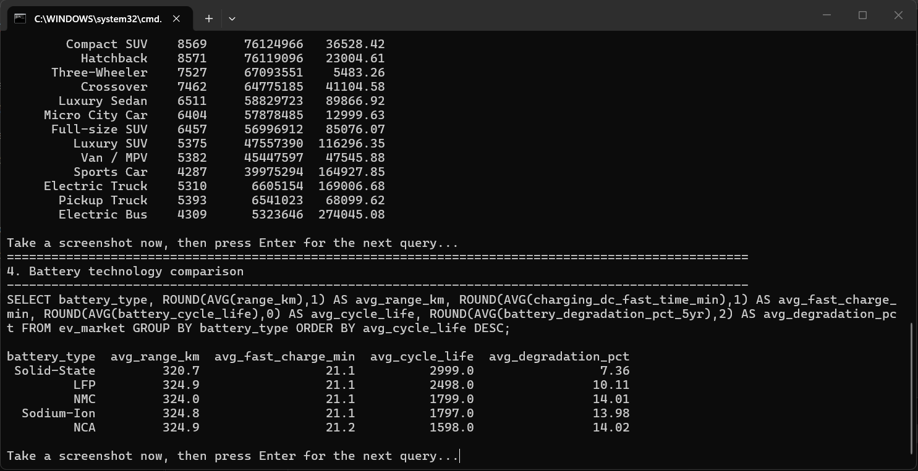
Figure 2. SQL output: battery technology comparison.
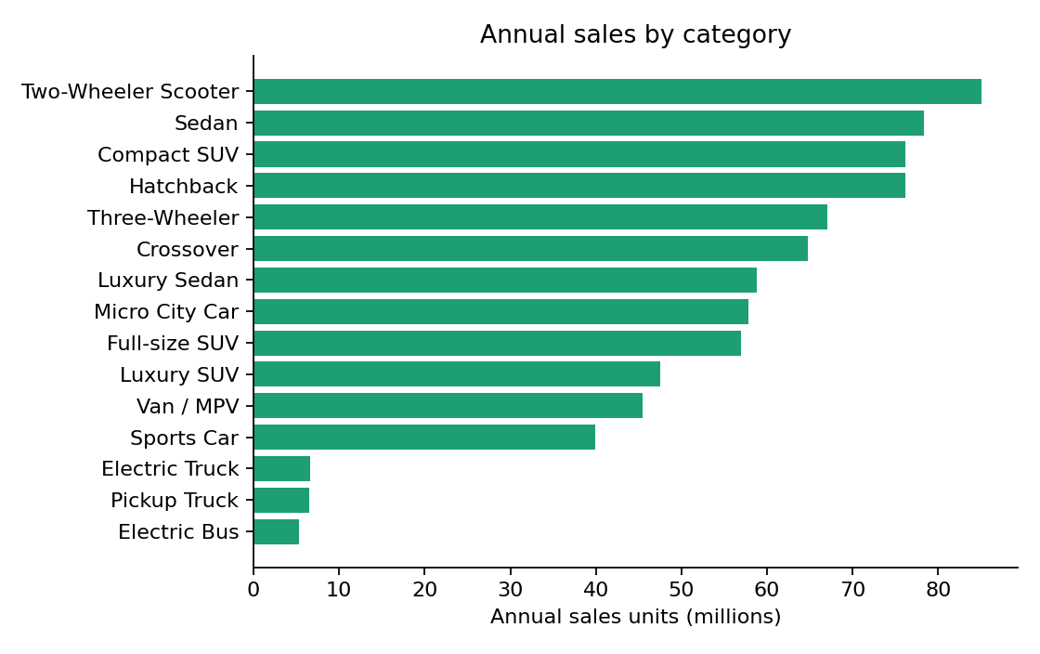
Figure 3. Annual sales by category.
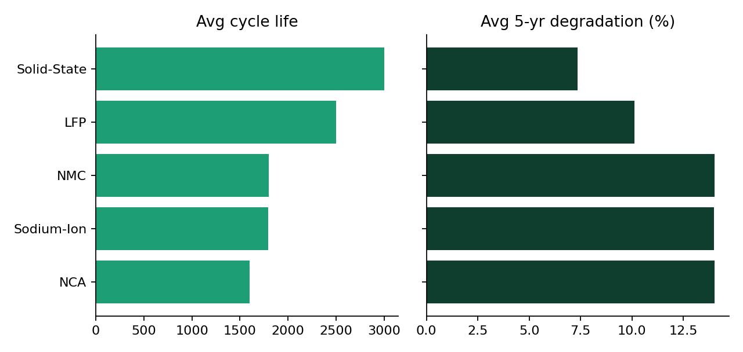
Figure 4. Average cycle life and 5-year degradation by battery type.
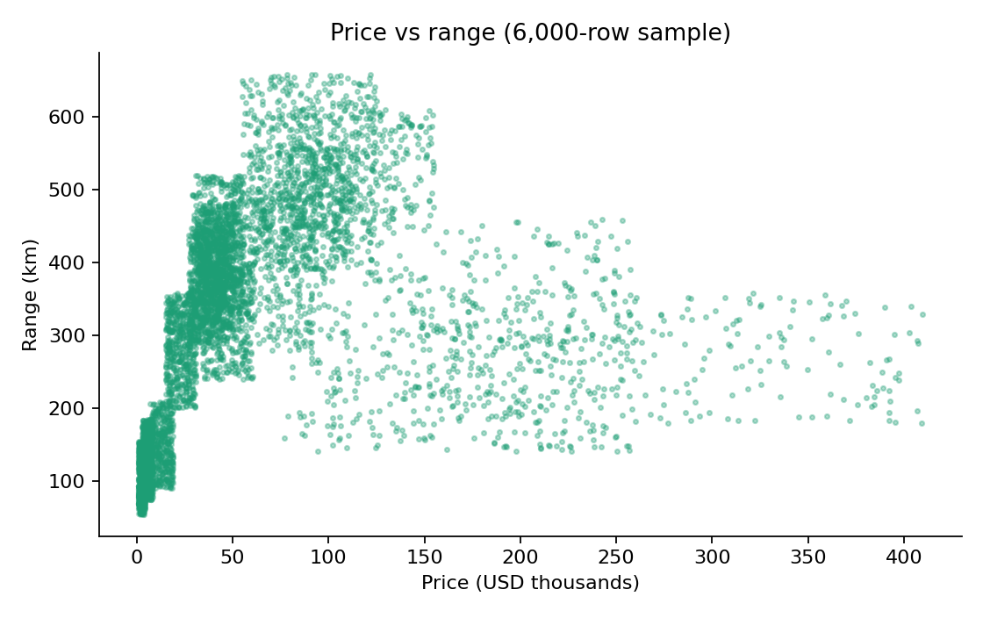
Figure 5. Price vs range (6,000-row sample).
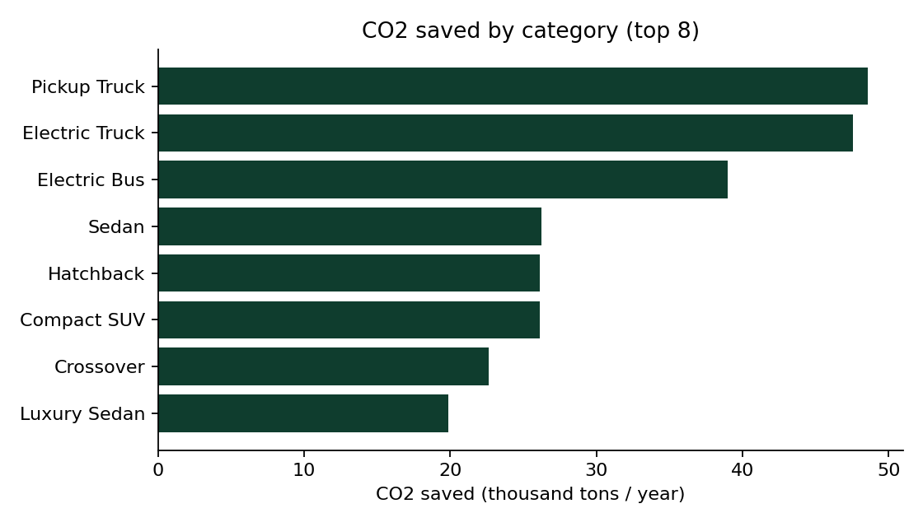
Figure 6. CO2 saved by category (top 8).
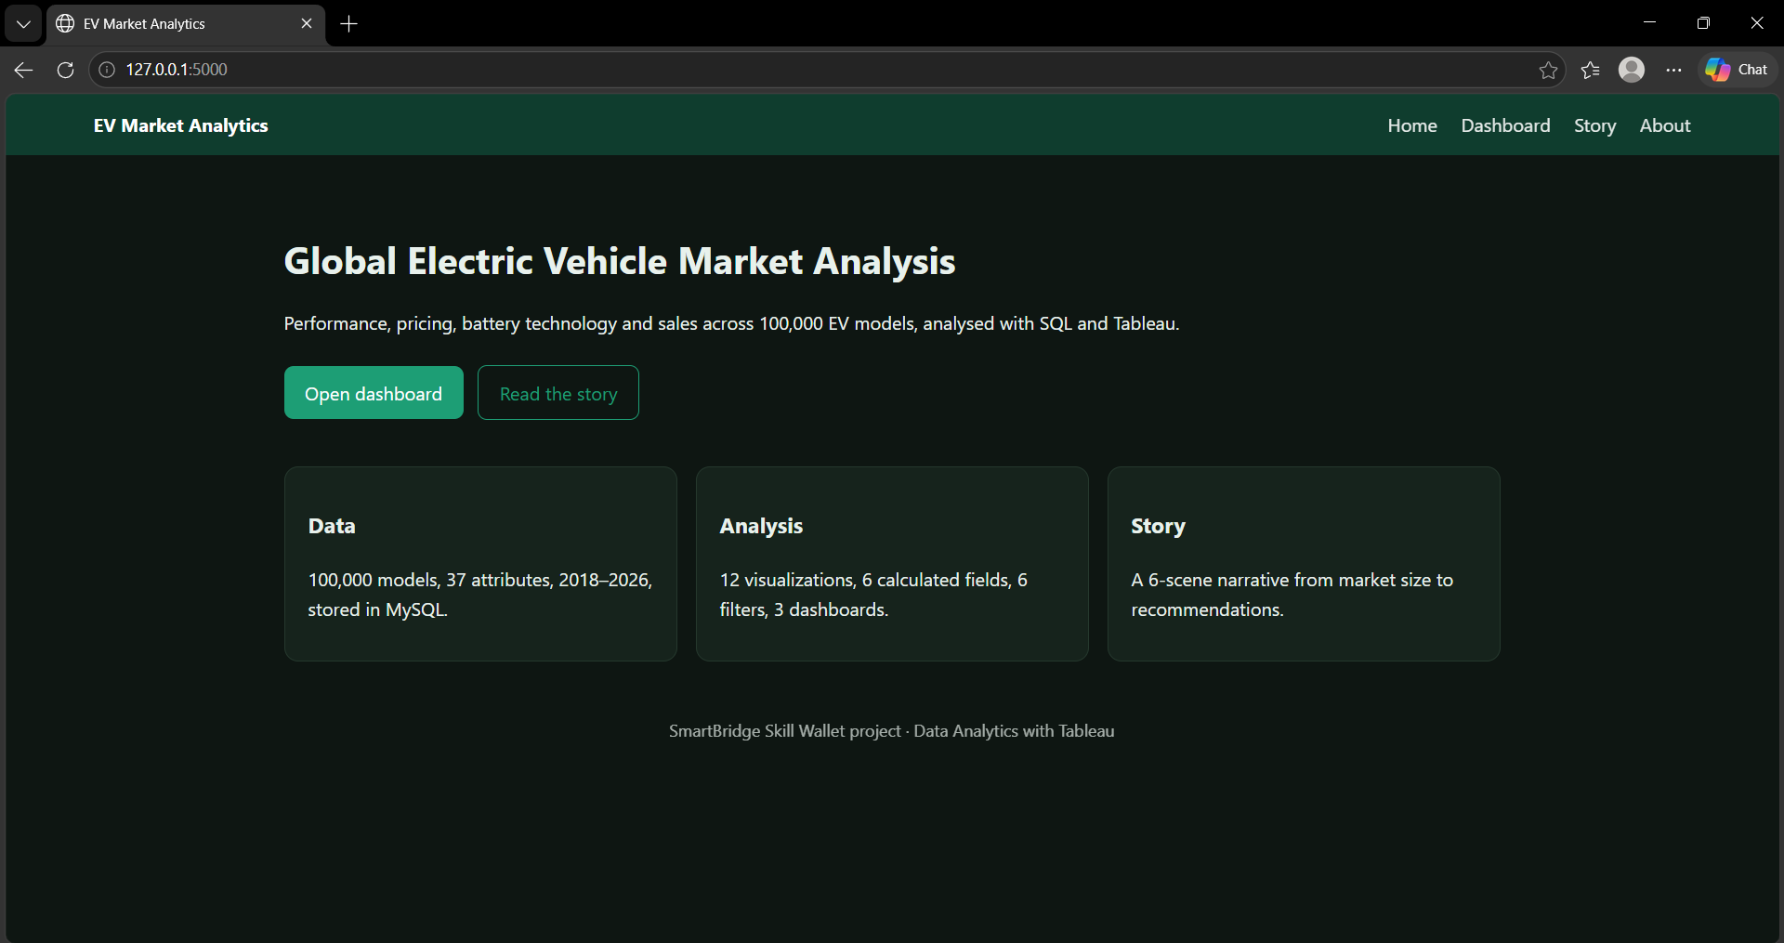
Figure 7. Home page of the Flask app running at 127.0.0.1:5000.
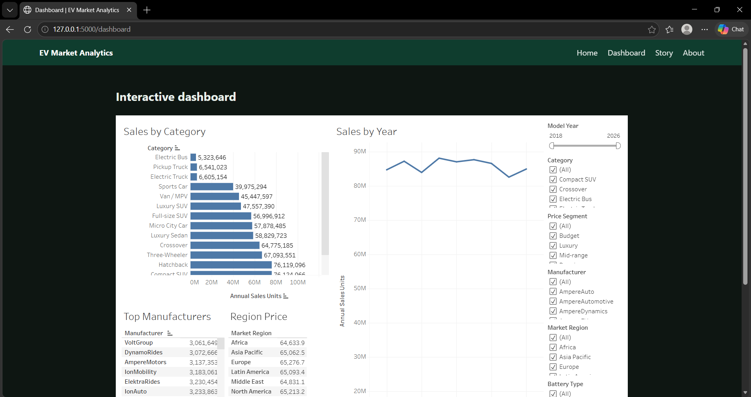
Figure 8. Dashboard page with the embedded Tableau dashboard and filters.
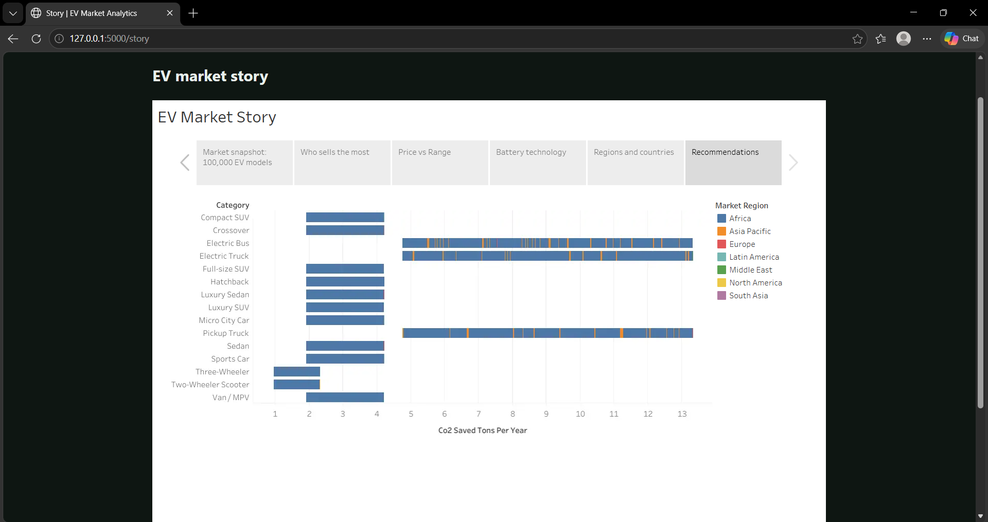
Figure 9. Story page with the six-scene Tableau story embedded.

Results summary
- Scooters lead volume: about 85.0M units, followed by sedans (78.3M) and compact SUVs (76.1M). Electric trucks, pickups and buses sell about 5 to 7M each.
- Price follows battery size: price correlates 0.84 with battery capacity but only 0.28 with range. Electric buses (about $274k) and trucks (about $169k) are the most expensive.
- Battery durability: Solid-State averages 2,999 charge cycles and 7.36% degradation over five years; LFP follows with 2,498 cycles and 10.11%. NMC, Sodium-Ion and NCA are between 1,598 and 1,799 cycles with about 14% degradation.
- No fast-charge or range gap: every battery type averages about 21 minutes for DC fast charging and 320 to 325 km of range.
- Balanced market: the top five manufacturers (SurgeWorks, CurrentMobility, ElektraMobility, VelocityMobility, WattDynamics) sell 4.6M to 4.9M units each, and regions are evenly split.
- Stable trend: average price (about $65k) and range (about 324 km) are flat from 2018 to 2026.

8. ADVANTAGES & DISADVANTAGES
Advantages | Disadvantages / limitations
Brings sales, price, battery and impact data into one interactive view. | The dataset is synthetic, so totals (about 773 million units) are relative measures, not real-world numbers.
Six shared filters make exploration across 100,000 models easy. | Models per year, regional totals and average range by battery type are almost uniform, so few patterns stand out.
SQL queries make every number checkable against a database. | Tableau Public connects to files, not database servers, so the SQLite database is not queried live.
Embedding in Flask gives a shareable web app without a custom charting library. | The Flask app runs locally and is not yet deployed to a cloud platform.
Top N and shared filters keep the dashboard responsive. | Outliers such as buses and trucks need category-level comparison to avoid misleading charts.

9. CONCLUSION
The project takes EV market data from a CSV file into a database, analyses it with SQL, visualizes it in Tableau and publishes the dashboard and story on a Flask website. The analysis shows which categories sell most, that battery size drives price, and that battery chemistry matters most for durability. Because the dataset is synthetic, the results are best read as relative comparisons within an academic project.

10. FUTURE SCOPE
- Add real-world data (registrations, charging stations) to replace synthetic fields.
- Add sales forecasting by category.
- Connect Tableau directly to a MySQL server with Tableau Desktop.
- Deploy the Flask app to a cloud platform.

11. APPENDIX

Source Code
Load script, SQL view, calculated fields and the Flask route are listed below. The full code is in the GitHub repository (scripts/load_to_db.py, sql/queries.sql).
import sqlite3
import pandas as pd

df = pd.read_csv("ev_market_test.csv")
con = sqlite3.connect("ev_market.db")
df.to_sql("ev_market", con, if_exists="replace", index=False)
print("Stored", len(df), "rows in table ev_market (database file: ev_market.db)")

CREATE VIEW vw_ev_clean AS
SELECT *, ROUND(range_km*1.0/price_usd*1000,2) AS range_per_1000usd,
CASE WHEN price_usd < 20000 THEN 'Budget' WHEN price_usd < 60000 THEN 'Mid-range'
WHEN price_usd < 120000 THEN 'Premium' ELSE 'Luxury' END AS price_segment
FROM ev_market WHERE price_usd > 0 AND range_km > 0;

Range per 1000 USD = [Range Km] / [Price Usd] * 1000
Price Segment = IF [Price Usd] < 20000 THEN "Budget" ELSEIF [Price Usd] < 60000 THEN "Mid-range"
ELSEIF [Price Usd] < 120000 THEN "Premium" ELSE "Luxury" END
Range Class = IF [Range Km] >= 450 THEN "Long" ELSEIF [Range Km] >= 250 THEN "Medium" ELSE "Short" END
Fast Charge Rating = IF [Charging Dc Fast Time Min] <= 15 THEN "Ultra-fast"
ELSEIF [Charging Dc Fast Time Min] <= 25 THEN "Fast" ELSE "Standard" END
Revenue (Est.) = [Price Usd] * [Annual Sales Units]
Sales Share = SUM([Annual Sales Units]) / TOTAL(SUM([Annual Sales Units]))

@app.route("/dashboard")
def dashboard():
return render_template("dashboard.html", viz_url=DASHBOARD_URL)

Dataset Link
ev_market_test.csv was provided by Skill Wallet (100,000 rows, 37 columns). The file is also in the GitHub repository folder used for this project.

GitHub & Project Demo Link
GitHub repository: https://github.com/NilamberHada/ev-market-tableau
Tableau Public dashboard: https://public.tableau.com/views/EVMarketAnalysis_17926786113420/MarketOverview
Tableau Public story: https://public.tableau.com/views/EVMarketAnalysis_17926786113420/Story1
Demo video: https://drive.google.com/file/d/1Oik0Z53AKzTwvmX7_oB2swu_yIT3qbFW/view?usp=drivesdk

Abbreviations
Term | Meaning
EV | Electric Vehicle
BI | Business Intelligence
KPI | Key Performance Indicator
CSV | Comma-Separated Values
SQL | Structured Query Language
LFP | Lithium Iron Phosphate
NMC | Nickel Manganese Cobalt
NCA | Nickel Cobalt Aluminium
DC | Direct Current
CO2 | Carbon dioxide
API | Application Programming Interface

Before submission: enter the Team ID, institution and course, and the submission date on the cover table.

